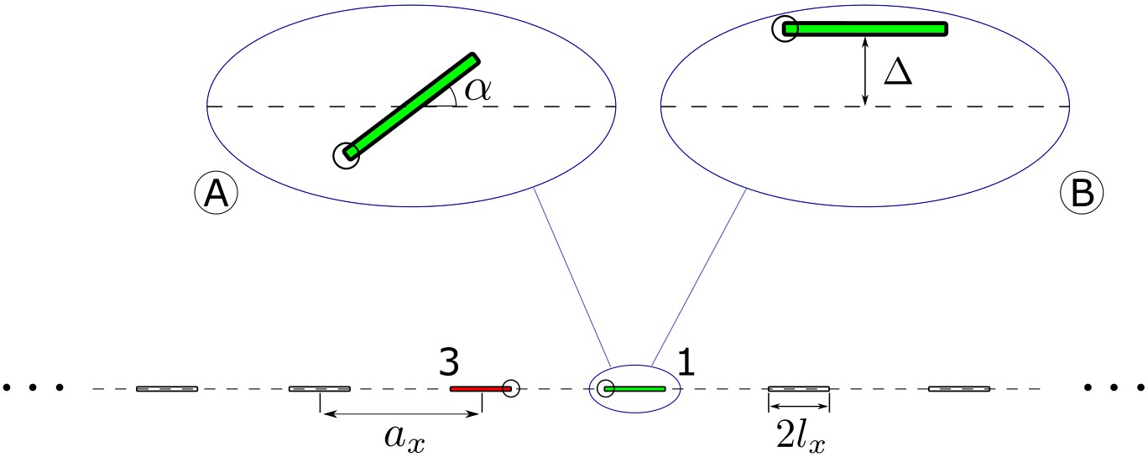

***4.1 Hydrostatic loading***(**) is of the main interest, since the effects of perturbation are not overshadowed by the factor of crack orientation with respect to applied load.

*The effects of perturbations on SIFs at the parent crack tips (prior to kinking)*. The maximal values of  were not always reached for a perfectly aligned crack (as may be intuitively expected) but for a somewhat perturbed configuration. Figure 3 shows the effect on  , as well as , (at the inner tips of cracks 1–4) produced by two types of perturbations of the position of crack 1: rotation on angle  and uplift translation on distance *.* The said maximums in  on cracks 1 and 4 (under rotation) and on cracks 1 and 2 (under uplift) may be explained simply by the reduction of spacing between the crack tips caused by the perturbations. The most interesting is the behavior of  at the tip of crack 3 (red solid line): The value of  is maximal at perturbed positions ( =20o in Fig. 3a, /*l= 0.54* in Fig. 3b, for the case ) – in spite of the fact that the spacing between the considered crack tip and the tip of the perturbed crack in the perturbed positions is larger than spacings in the unperturbed position.

|  |  |
| --- | --- |
|  |  |
| a | b |
|  |  |
| c | d |
| Fig. 3. Mode I and II SIFs (normalized to the SIF  of a single horizontal crack of the same length) at the inner tips of cracks 1–4 (denoted by numbers in squares) for various rotation angles  and uplift displacements /*l* of the crack 1; hydrostatic loading. | |

The extremums related to crack 3 can be explained by *mixed-mode interactions.* Indeed, the effect of mode I at crack 1 on  at the considered tip of crack 3 is obviously maximal at the unperturbed position; hence, at small perturbations, its rate of change (the derivative) is zero implying that the said effect is only slightly weaker in a somewhat perturbed position. On the other hand, the effect of mode II at the perturbed crack 1 on  at crack 3 (that is zero in unperturbed configuration where mode II is absent) has finite rate of increase under small perturbations; thus the *combined* effect of both modes (on the perturbed crack) on  on the unperturbed crack is stronger for a slightly perturbed configurations. We emphasize that these considerations refer to *small* perturbations (at large ones, these effects may be overshadowed by interactions with other neighbors).

Similar explanation (mixed-mode interaction) can be given for the behavior of  at some of the other crack tips. As noted above, some of these maximums are strongly pronounced; this can be attributed to the fact that, in addition to the mixed-mode interaction, the  values are also enhanced by the reduction of spacings between the neighboring tips due to perturbations. As shown in Section 4.2, this effect is observed even for uniaxial tension (where it is overshadowed by the crack orientation with respect load direction).

*The effects of perturbations on SIFs and ERR with the account of kinking.*  We now assume that the applied loads are sufficiently high to produce propagation on the cracks where the critical conditions are reached. Mixed-mode crack tip conditions result in kinking, at certain angle  that depends on the ratio  on the parent crack tip (prior to kinking). The mentioned extremal properties of the perturbed configurations caused by mixed-mode interactions, observed for  at the parent cracks (Fig. 3), are more pronounced for  and  at tips of kinked cracks, as seen from Figure 4. The latter also gives kink angles ; (their positive directions are shown in Fig. 5). The values of kink angles , relative SIFs  and  , and ERR  were determined by (a) using formulas (6) and (7) (solid lines); (b) using the maximal ERR criterion and Amestoy and Leblond’s calculations of SIFs at the kink tip (denoted by circles), and (c) using the maximal ERR criterion and Cotterell and Rice’s formulas (dotted lines; they almost coincide with the solid lines – one notices only a slight difference between them in Fig. 4f).

These results may be interpreted in the sense that crack configurations with perturbed symmetry may be energetically preferable, as compared with the ones having perfect symmetry (assuming, of course, that the crack array is “free” to evolve in the ways that include symmetric and perturbed patterns and there is no direction dependence of fracture toughness (Pronina *et al*, 2020)).

|  |  |
| --- | --- |
|  |  |
| a | b |
|  |  |
| c | d |
|  |  |
| e | f |
| Fig. 4. Mode I SIFs and ERR with account of kinking (normalized to the values  and for a single horizontal crack of the same length) and kinking angles  at the inner tips of cracks 1–4, for various rotation angles  and uplift displacements /*l* of the crack 1; hydrostatic loading. Solid lines correspond to formulas (6) and (7), circles to the maximal ERR criterion and Amestoy and Leblond’s calculations, and dotted lines to the maximal ERR criterion and Cotterell and Rice’s formulas. | |

|  |
| --- |
|  |
| Fig. 5. Positive directions of kink angles |

The plots of  are not shown since their values are close to zero (normalized values are smaller than 10-2 ) thus confirming closeness of the results corresponding to the local symmetry, maximal ERR, and maximal hoop stress criteria.

Thus, the results obtained by using the maximal hoop stress criterion and the maximum ERR criterion (based on Cotterell and Rice’s formulas) almost coincide with one another; the results obtained by using Cotterell and Rice’s formulas and the Amestoy and Leblond’s calculations (combined with the maximum ERR criterion) differ slightly only in the vicinity of their extremal values (and this slight difference is noticeable only on crack 1). Although the difference in kink angles may reach 5%, the difference between predictions of formulas (7) and our calculations that utilize Amestoy and Leblond’s results combined with the maximal ERR criterion is much smaller.

*Effect of perturbations on kink orientation and on the stability of symmetric configuration*s. We now examine whether the kink direction tends to return to the unperturbed crack orientation (direction stability) and, also, whether it contributes, in the terminology of Melin (1983), to crack “avoidance of each other”. Figures 4e,f for kink angles for four parent crack tips show that, at all these tips, the kinks, when they form, tend to increase their deviation from the original crack orientation (at least, for a small perturbation). Moreover, our results demonstrate the tendency of “avoidance” for collinear neighbors at small perturbations; for larger perturbations, this may not be the case: e.g., the interaction between cracks 2 and 4 may be dominated by their interaction with crack 1 that may become closer to them due to the perturbation (to crack 4 for rotation and to crack 2 for uplift).

***4.2 Uniaxial loading***(**) is of the main interest, since the effects of perturbation are not overshadowed by the factor of crack orientation with respect to applied load.

*The effects of perturbations on SIFs at the parent crack tips (prior to kinking)*. The maximal values of  were not always reached for a perfectly aligned crack (as may be intuitively expected) but for a somewhat perturbed configuration. Figure 3 shows the effect on  , as well as , (at the inner tips of cracks 1–4) produced by two types of perturbations of the position of crack 1: rotation on angle  and uplift translation on distance *.* The said maximums in  on cracks 1 and 4 (under rotation) and on cracks 1 and 2 (under uplift) may be explained simply by the reduction of spacing between the crack tips caused by the perturbations. The most interesting is the behavior of  at the tip of crack 3 (red solid line): The value of  is maximal at perturbed positions ( =20o in Fig. 3a, /*l= 0.54* in Fig. 3b, for the case ) – in spite of the fact that the spacing between the considered crack tip and the tip of the perturbed crack in the perturbed positions is larger than spacings in the unperturbed position.

|  |  |
| --- | --- |
|  |  |
| a | b |
|  |  |
| c | d |
| Fig. 6. Mode I and II SIFs (normalized to the SIF  of a single horizontal crack of the same length) at the inner tips of cracks 1–4 (denoted by numbers in squares) for various rotation angles  and uplift displacements /*l* of the crack 1; hydrostatic loading. | |

The extremums related to crack 3 can be explained by *mixed-mode interactions.* Indeed, the effect of mode I at crack 1 on  at the considered tip of crack 3 is obviously maximal at the unperturbed position; hence, at small perturbations, its rate of change (the derivative) is zero implying that the said effect is only slightly weaker in a somewhat perturbed position. On the other hand, the effect of mode II at the perturbed crack 1 on  at crack 3 (that is zero in unperturbed configuration where mode II is absent) has finite rate of increase under small perturbations; thus the *combined* effect of both modes (on the perturbed crack) on  on the unperturbed crack is stronger for a slightly perturbed configurations. We emphasize that these considerations refer to *small* perturbations (at large ones, these effects may be overshadowed by interactions with other neighbors).

Similar explanation (mixed-mode interaction) can be given for the behavior of  at some of the other crack tips. As noted above, some of these maximums are strongly pronounced; this can be attributed to the fact that, in addition to the mixed-mode interaction, the  values are also enhanced by the reduction of spacings between the neighboring tips due to perturbations. As shown in Section 4.2, this effect is observed even for uniaxial tension (where it is overshadowed by the crack orientation with respect load direction).

*The effects of perturbations on SIFs and ERR with the account of kinking.*  We now assume that the applied loads are sufficiently high to produce propagation on the cracks where the critical conditions are reached. Mixed-mode crack tip conditions result in kinking, at certain angle  that depends on the ratio  on the parent crack tip (prior to kinking). The mentioned extremal properties of the perturbed configurations caused by mixed-mode interactions, observed for  at the parent cracks (Fig. 3), are more pronounced for  and  at tips of kinked cracks, as seen from Figure 4. The latter also gives kink angles ; (their positive directions are shown in Fig. 5). The values of kink angles , relative SIFs  and  , and ERR  were determined by (a) using formulas (6) and (7) (solid lines); (b) using the maximal ERR criterion and Amestoy and Leblond’s calculations of SIFs at the kink tip (denoted by circles), and (c) using the maximal ERR criterion and Cotterell and Rice’s formulas (dotted lines; they almost coincide with the solid lines – one notices only a slight difference between them in Fig. 4f).

These results may be interpreted in the sense that crack configurations with perturbed symmetry may be energetically preferable, as compared with the ones having perfect symmetry (assuming, of course, that the crack array is “free” to evolve in the ways that include symmetric and perturbed patterns and there is no direction dependence of fracture toughness (Pronina *et al*, 2020)).

|  |  |
| --- | --- |
|  |  |
| a | b |
|  |  |
| c | d |
|  |  |
| e | f |
| Fig. 7. Mode I SIFs and ERR with account of kinking (normalized to the values  and for a single horizontal crack of the same length) and kinking angles  at the inner tips of cracks 1–4, for various rotation angles  and uplift displacements /*l* of the crack 1; hydrostatic loading. Solid lines correspond to formulas (6) and (7), circles to the maximal ERR criterion and Amestoy and Leblond’s calculations, and dotted lines to the maximal ERR criterion and Cotterell and Rice’s formulas. | |